7.1.1 Inverted Star Pattern

Aim: Write a Python program to print an inverted right-angled triangle star pattern.
Algorithm
- Start
- Input value n
- While n > 0:
- Print "*" repeated n times
- Decrease n by 1
- Stop
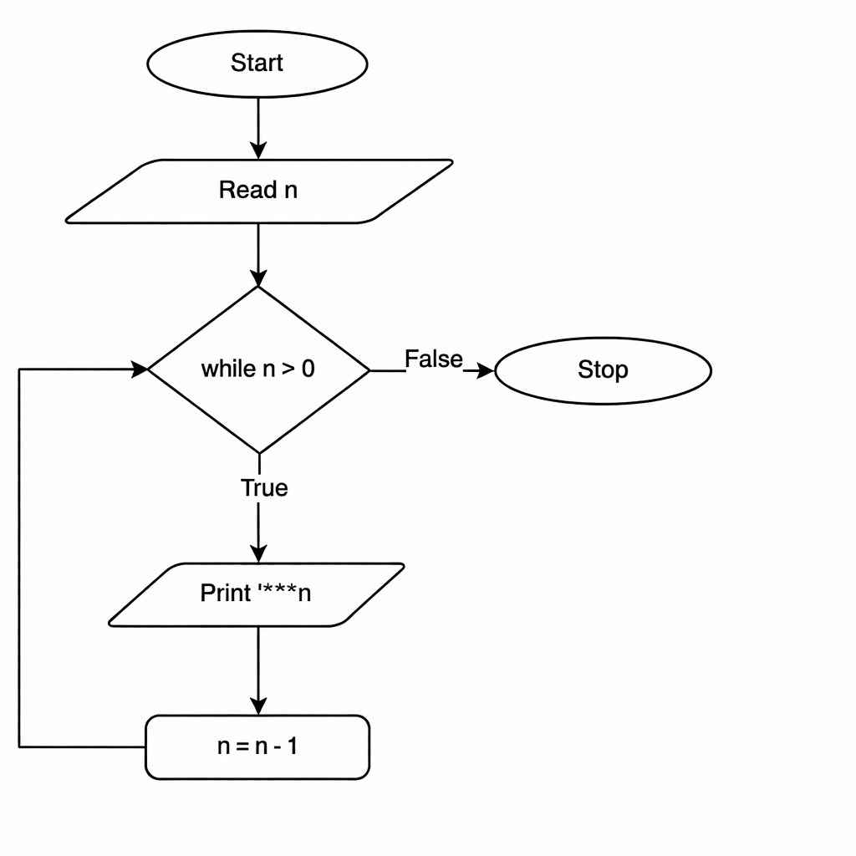
EXECUTION
